Student Aspirations Team: work so far

Actions
- Playground project
  - Building respect
  - Small step, but will lead to bigger things.
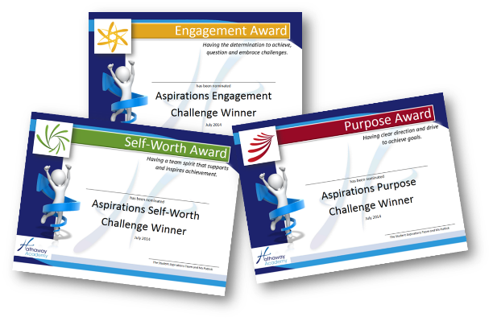
- Culture for Learning Challenge and Awards
  - These awards highlighted the CfL and built on the respect in classrooms by highlighting examples of aspirational attitudes.
  - The awards motivated and inspired others to do the same.
  - The Aspirations Team were able to make their role in the Academy clear.

- Logos and Slogans for Faculties
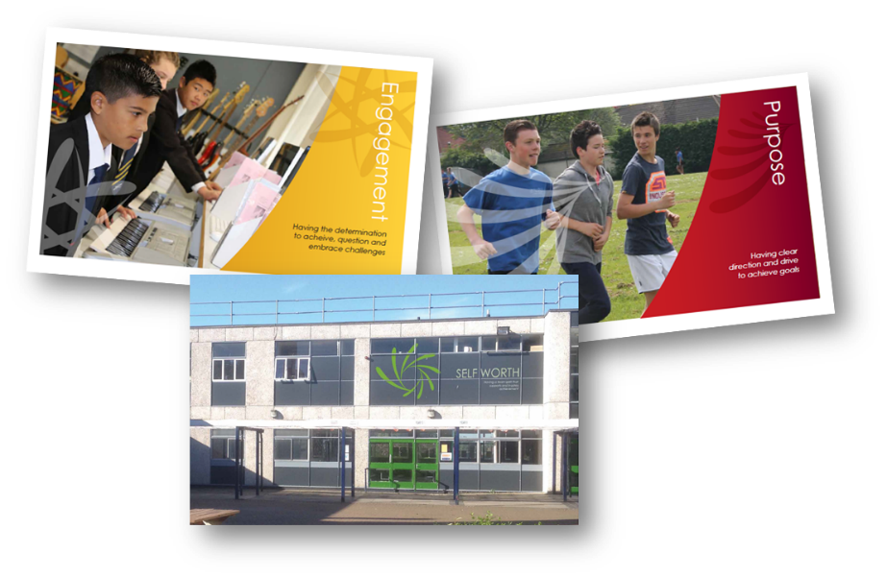
  - Worked together to create and everyone needs to see the importance.
  - Each logo and slogan was created by us and has a valuable meaning.

- They are EVERYWHERE in the academy – constant reminders and motivate everyone.
- Visible sign of what we believe and know will make us outstanding.
- All faculties, staff and students now have a clear vision of their drive and what our collective values are.

- New Staff are greeted by the Aspirations team as ambassadors for the academy – interview, tour, share aspirations vision.
- A PXS project was designed by the Aspirations Team to highlight the values and beliefs we want to see lived out in the academy.
- Facebook Articles – let everyone know what we stand for and what we are doing.
- Staff and Student relationships have also been explored through the use of interview questions that have focused on the Faculty names and Aspirations. The feedback from this is being use to highlight the progress we have made and the progress we have made on our journey.
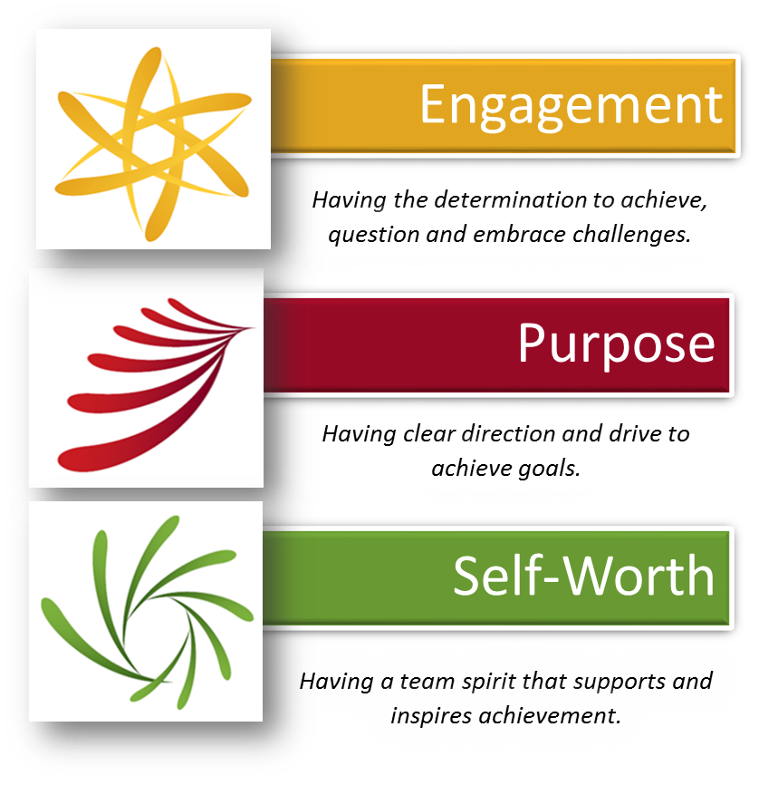

Summer 2015 Focus

The Student Aspirations Team are now moving to a new phase and will be focusing on Pride in Work. This project will involve:
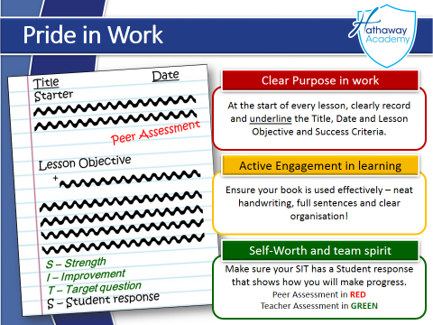
- Research and Student Voice work to establish where we are and what Pride in Work looks like
- Raising the expectations of Pride in Work
- Creating more awareness of Pride in Work
- Celebrating Pride in Work
- Nurturing a Pride in Work – consistency across the academy

