111

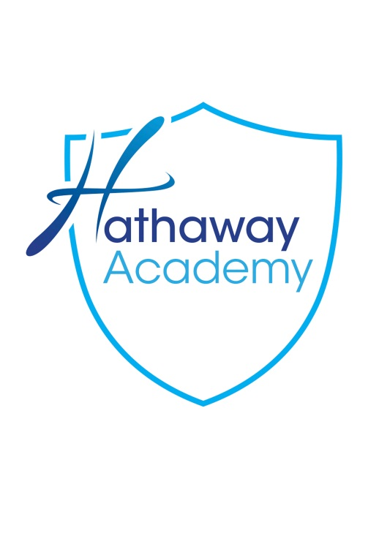

KEY STAGE 4
CHOICES
2019 - 2021

Your guide to KS4 subjects

Pathway A

KEY STAGE 4 SUBJECT CHOICES 2019-21

Introduction

At The Hathaway Academy, we are determined to ensure that all our students have a personal pathway to success between the ages of 14 and 16 and beyond. We will offer an appropriate pathway for each student to enable them to reach their full potential and we will direct them towards the pathway most suited to their needs. They will then be able to make their choices as to which subjects they wish to study. Students will be following a learning pathway that will enable them to build on their strengths, interests and career ambitions.

You son/daughter’s programme for the next two years will build on their current attainment and ensure they take the most suitable range of courses to enable them to reach their academic potential. It is vital that you take the time to discuss and evaluate all the choices available and allow your child to make an informed decision which will shape their future.

During the first three years (Key Stage 3) students have followed the National Curriculum. At Key Stage 4 (KS4) there is a smaller compulsory element to the curriculum and more opportunities for student choice. This booklet contains details of the option process and the type and range of subjects available at the Academy. Both parents and students are urged to read it carefully. The Academy will continue to offer a range of qualifications that enables all our learners to access qualifications that are suitable to their needs and have a post 16 progression route. Students should think carefully about these as access to quality training and further employment opportunities will rely upon informed decisions made with their option choices during Year 9.

What is meant by the term “Options”?

Until the end of Year 9, students follow a compulsory curriculum comprising a combination of core and foundation subjects. At Key Stage 4 an element of choice is introduced and students are able to select a range of subjects they wish to study at public examination level. Students will be required to make a selection in option blocks.

What qualifications are available?

At The Hathaway Academy, we offer a range of qualifications at two levels within the National Qualification Framework: Foundation Tier qualifications leading to an award of a GCSE grade(s) between 4 and 1 (or equivalent) or Level 2 qualifications leading to an award of a GCSE grade(s) between 9 and 5 (or equivalent).

There are two types of qualification at both levels. GCSE is the traditional type offered by many subjects, or a qualification which offers a more vocational programme, leading to the award of the equivalent of one GCSE.

Government changes to the exam system and qualifications mean that students will be studying new GCSEs in subjects with a new grading scale of 1 to 9, with 9 being the top grade.

Core Curriculum

Students will follow a core curriculum consisting of English Language, English Literature, Mathematics, Double Science, Physical Education and Certificate in Business & Enterprise. They will also make a choice as to whether they study Geography or History.

How do I select my Options?

In addition to the core curriculum, students will be required to make a selection in option blocks. For option 1 students will make a choice between Geography and History. For options 2 and 3 they may choose any combination of subjects from the list which are not duplicates. They must include, in addition to their option choices, 2 reserve choices. These can be a combination of GCSEs or GCSEs and BTEC courses.

Every effort will be made to ensure that as many first choice requests are granted as possible. If courses are under-subscribed they may not run. If courses are over-subscribed appropriate criteria will be applied to fill the places available and this may involve an interview. Unsuccessful applicants will be offered a place on their second choice course, if possible.

Your child needs to complete the options form and hand it in to Student Reception. The completed options form must be returned on Monday 4th March to student reception, following the options evening on Wednesday 27th February 2019; use the evening as an opportunity to ask any questions and finalise the form. The closing date is 4th March 2019.

The Academy will endeavour to meet all requests. However, if it is not possible to provide the subjects requested a meeting will be arranged with the student and, if necessary, the parents, to discuss an alternative selection.
COMPLETED OPTIONS FORMS SHOULD BE RETURNED TO STUDENT RECEPTION NO LATER THAN MONDAY 4TH MARCH 2019.

Choosing your options may seem a daunting task but it is a very exciting step towards your on-going education. Whether the option subjects you take will lead you to your future career path or not, you will have gained a wealth of experience from which to base your future decisions.
You will need to do a little research with your parents/carers before making decisions - think about:

What motivates and interests you?
What makes you work hard?
What is your dream job?

After all, the most successful people choose a career path that involves what they enjoy doing and what they are good at. Have a go at the quiz; tick anything that you enjoy doing or think that you would enjoy doing.

A
Building things
Being active and working outdoors
Making and fixing things
Using tools and machines
Solving problems

B
Designing and displaying things
Being on television
Writing a book
Playing in a band
Doing a makeover

C
Helping people
Sorting out arguments
Showing people what to do
Looking after people
Doing voluntary work

D
Finding out how things work
Doing experiments
Researching and testing ideas
Designing a new computer game
Doing calculations

E
Organising parties & other social events
Buying and selling things
Running a business
Entering competitions
Campaigning for change

F
Making plans
Using a computer and calculator
Arranging things over the phone
Putting CDs/DVDs into the right order
Organising your money

How many ticks did you get in each section? Write your scores in the boxes below. Most people have more than one interest so check out any score of three or over.

A |  | B |  | C |  | D |  | E |  | F
Look at the subject ideas to help you choose your Key Stage 4 options and Further Education; this will give you a guide towards the subjects in which you are likely to excel.

Mostly As
You seem to like practical work. Look for options where you can use your practical skills, do something active and work on different types of projects.
Subject ideas:
Food Technology, Physical Education.

Mostly Bs
You sound creative. Look for options where you can express yourself and work on new ideas.
Subject ideas:
Art, Media, Drama, Music, Photography.

Mostly Cs
You seem to be a sociable person. Look for options where you can work with other people and find out more about how the society works.
Subject ideas:
Media, Religious Studies, Business Studies, Travel and Tourism.

Mostly Ds
It seems that you like investigating things. Look for options where you can use your number and thinking skills to find out more about why things are the way they are.
Subject ideas:
Biology, Chemistry, Geography, History, Mathematics, Physics, Statistics.

Mostly Es
You sound like an enterprising person. Look for options where you can use your energy, communication, number and thinking skills to test your ideas about how to improve the world.
Subject ideas:
Business Studies, Information Technology (IT), Modern Foreign Languages.

Mostly Fs
Being well organised seems important to you. Look for options where you can use your planning, computer skills to find out more about the systems and structures that keep the world working properly.
Subject Ideas:
Business Studies, History, Information and Communication Technology (ICT).

IT IS VERY IMPORTANT TO REMEMBER THAT ALL EMPLOYERS WILL BE LOOKING FOR A GRADE ‘C’ OR ABOVE IN ENGLISH AND MATHS. You will need to bear this in mind when choosing your option subjects to ensure that you have not chosen a subject that you find too difficult as this could affect your English and Maths studies.

Do your research

When you know exactly what your options are, you can research those that interest you. Use the checklist below to make sure that you don’t forget anything:

- Read all the options information that the Academy gives you
- Check which subjects are compulsory - the ones you have to do
- Talk to the teachers to see if they think that it is a good idea that you do their course
- Talk to your parents and find out what options they think you should do and why
- Go with your parents to information events
- Look up the careers that interest you in the Careers Resource Centre to find out what subjects, qualifications and grades you will need for these careers
- Speak to the Careers Advisor at the Academy about your options choices and career ideas
- Visit www.nationalcareersservice.direct.gov.uk for further advice
- Find out what Apprenticeships could offer you at age 16 or older, and what you would need to get one - see www.apprenticships.org.uk
- Access a unique online careers matching and information programme called Kudos. Find out how to access it from your Careers Advisor

Good luck and enjoy this exciting step in your journey towards your dream career.

Art, Craft and Design GCSE

What will I be taught?
OCR
GCSE Art, Craft and Design is aimed at turning students into accomplished artists. The Art department’s aim is to develop students’ traditional artistic skills such as painting and drawing and also to develop their ability to think creatively and critically about their artistic practice.

Students will be introduced to a wide range of artistic techniques including mastering acrylic paint and tonal drawings, as well as experimenting with a variety of printing techniques, experimenting with wire, clay and 3D methods of design. Students are encouraged to work in a variety of different mediums and explore the use of computer aided design as well as traditional techniques.

Students will respond critically and creatively to a wide range of contemporary artists, being inspired by their own interests. They are encouraged to work independently with a strong focus on producing work that is personal to them.

We recommend that students have their own watercolour and acrylic paints, and a set of drawing pencils (6B, 4B, 2B, HB, 2H) so they can practise techniques they have learnt in class. We also recommend that students have access to a digital camera so they can create images they can work from in class.

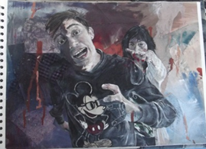

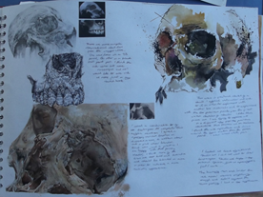

What type of student is best suited to How will I be assessed?
this course?

60% Portfolio and 40% Exam
Students will work on two projects for their portfolio. They will choose one project and develop this. The exam involves 10 weeks of preparatory work based around a theme given to students by the examining board. Students must conclude this project with a 10 hour final piece completed in exam conditions.

A student who is passionate about Art, who enjoys thinking creatively and creating work that they can be proud of. A student who is not afraid to make mistakes and take risks with their ideas.

What qualification will I gain?
What will the home learning be like?
What could I do with this qualification?

Qualification gained: GCSE Art, Craft and Design.

Students could use this qualification to pursue a career in the creative industries. Careers in the arts include: fine artist, graphic designer, illustrator, web designer, film director, set designer, animator, product designer, Art teacher, visual FX artist.
Home learning will be given every two weeks in the first half term of the course based around developing the skills learnt. It then becomes much more of an independently driven exercise and students are given individualised tasks. Those who obtain the best grades go above and beyond the tasks set and produce their own work inspired by the themes.

What websites, books and other resources will help with my learning?

Books: Websites:
The Art Book published – Phaidon www.tate.co.uk
BBC Bitesize GCSE Art and Design www.npg.org.uk
The Twentieth Century Art Book - Phaidon www.saatchigallery.com
Art Now - Taschen www.thisicollassal.com
50 Photographers You Should Know - Prestel
50 Artists You Should Know - Prestel
50 British Artists You Should Know - Prestel
50 Contemporary Artists You Should Know - Prestel
Creative Paint Workshop for Mixed-Media Artists - Ann Baldwin
Artists’ Journals and Sketchbooks - Lynne Perella
Extraordinary Sketchbooks - Jane Stobart

NCFE Level 2 Certificate in Business & Enterprise

What will I be taught?
NCFE 14-16 Certs
Throughout this course various skills will be developed including communication, application of number, IT, working with others, improving own learning independently and project-based learning.

The following topics will be examined in the order presented:

Unit 01: Introduction to Business and Enterprise

This unit aims to give learners an introduction to business and enterprise. It gives them an introduction to start-up projects and helps them to identify risks and rewards.

Unit 02: Marketing for Business and Enterprise

This unit aims to give learners an insight into market research and different marketing opportunities and techniques.

Unit 03: Finance for Business and Enterprise

This unit aims to provide learners with a basic knowledge and understanding of business finance for a new business or enterprise.

Unit 04: Plan, Develop and Participate in a Business or Enterprise Project

This unit aims to develop a project plan and implement the project. The learner will then go on to evaluate the overall success of the project.

What type of student is best suited to How will I be assessed?
this course?

Unit 1: Coursework based and internally assessed
Unit 2: Externally assessed (exam)
Unit 3: Coursework based and internally assessed
Unit 4: Internally assessed
The NCFE qualification in Business and Enterprise will suit students who can produce a good standard of coursework and get involved in project work.

What qualification will I gain?
What will the home learning be like?
What could I do with this qualification?

The qualification that you will gain is a Level 2 vocational qualification which is equivalent to a GCSE. This will enable you to progress on to a Level 3 qualification such as:
- NCFE Level 3 Certificate in Principles of Business and Administration
- NCFE Level 3 NVQ Certificate in Business and Administration
Your home learning will consist of different tasks including reinforcing your knowledge and understanding of your classwork by completing home learning worksheets. You will be expected at times to carry out research from a given topic.

What websites, books and other resources will help with my learning?

BBC Bitesize – GCSE Business Studies

Web: www.ncfe.org.uk

Level 2 Certificate in Digital Applications

What will I be taught?
Pearson
The CiDA qualification is ideal for students who want the opportunity to explore and acquire a broad understanding and knowledge of the creative digital industries, and gain the ability to apply that knowledge in practical contexts.

You will learn how to use many different types of computer software such as:

- Photoshop: which will help you create computer generated art work by editing and altering images.

- Dreamweaver: which is software used to design professional-looking websites.

- Flash animation: which will help you create animated designs.

This course is very much project based learning, where you will use your ICT skills to develop artwork and imaging based on a project brief.

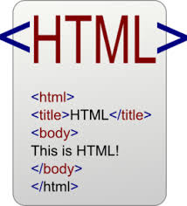

What type of student is best suited to How will I be assessed?
this course?

CiDA consists of 2 units:
Unit 1, Developing Web Products, is a mandatory unit which accounts for 25% of the qualification.
One of the following optional units makes up the remaining 75%:
- Unit 2 - Creative Multimedia
- Unit 3 - Artwork and Imaging
- Unit 4 - Game Making
Students who enjoy using computers and are willing to learn how to use new types of software.

Problem solvers. You will be expected to explore how to use different aspects of the computer and learn through trial and error.

What qualification will I gain?
What will the home learning be like?
What could I do with this qualification?

You will achieve a Level 2 Certificate in Digital Applications.

After completing a CiDA qualification, you will have the foundation of knowledge and skills you need to progress to further study of computing and IT-related courses at Level 3.
Home learning will be weekly and it will be used to support your progress in the completion of your course project. This will include:

- Research tasks
- Completion of project-related tasks.

What websites, books and other resources will help with my learning?

https://qualifications.pearson.com/en/qualifications/digital-applications-cida-dida/about.html

Drama

What will I be taught?
AQA
A GCSE in Drama is an exciting opportunity, and the skills are transferable to many career paths. Students will develop their confidence in personal presentation as well as growing communication skills, working with a range of people and exploring the many forms theatre can take.

The study of drama will include the detailed exploration of acting skills, with focus on movement, vocal work and group-work skills. Additionally, students will learn how to create characters and develop characterisations through the detailed analysis of text and practical exploration. Students will have an opportunity to challenge and understand the social, historical and political contexts of play texts, and begin to develop an understanding of the many elements that make up a piece of theatre.

The first year of study will focus on the development of the skills required. Students will study one of the following plays: Blood Brothers, Hansel and Gretel, 39 Steps, The Crucible, Noughts and Crosses or A Midsummers Night’s Dream. Students will produce a full production of this play as this is what they will write about in the written exam. Towards the end of the first year students will focus on a monologue; this will be their first extract for Component 3. The second extract will be from the same play and this will be completed in the second year of study. Students should be prepared to perform alone. Component 2 will be started at the beginning of the second year of study; students will carry out a range of workshops and then use what they have discovered to create their own devised performances.

A GCSE in Drama is not for the faint hearted; it requires dedication and ambition. We want students to develop opinions and their own creative style. We will encourage parents and carers to support our students by being warm audiences to the work they produce. Drama is a unique opportunity for students to showcase exactly what they have created.

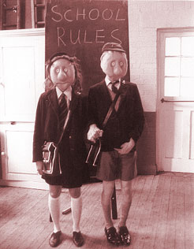

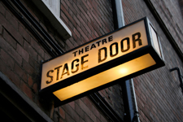

What type of student is best suited to How will I be assessed?
this course?

The examinations for GCSE Drama are made up of 3 Components. Component 1 is an open book written exam of a play that has been studied practically (40%). Component 2 is a devised practical that is accompanied by a devising log (40%). Component 3 is a practical exploration of texts in practice (20%).
A confident, resilient and positive outlook is vital for the study of Drama. Organisation and drive are also key skills, as note-taking is essential to keep up-to-date with your progress. Being prepared to experiment and try things out are also necessary skills. DO NOT take Drama if you do not like performing; it is key.

What qualification will I gain?
What will the home learning be like?
What could I do with this qualification?

Home learning will mainly involve the writing up of what has been done in lessons as a log of the work carried out and how they are developing. It will also involve research tasks, learning lines and developing ideas. It may involve writing reviews of work seen in class or as part of an organised trip. Students need to be prepared to attend extra rehearsals outside of timetabled lessons.
Ex-Drama students from this Academy work in the performing arts industry, as actors, technicians and events co-ordinators, but the majority work in all manner of employment, from teaching, nursing, estate agents, retail, finance, chemists etc.

What websites, books and other resources will help with my learning?

BBC Bitesize: http://www.bbc.co.uk/education/subjects/zbckjxs

Stage Works: http://www.stagework.org.uk/stageworks/index.html

Careers: https://nationalcareersservice.direct.gov.uk/advice/planning/jobfamily/Pages/perfartsbroadcastandmedia.aspx

Get into Theatre: http://ccskills.org.uk/careers/advice/any/theatre

Technical theatre: http://www.theatrecrafts.com/page.php?id=30

GCSE English Language and English Literature

What will I be taught?
AQA
Students will follow a combined course which includes English Language and English Literature. This will result in students receiving two GCSEs.

They will follow the AQA Specification for both English Language and English Literature. Both Language and Literature GCSEs are 100% assessed by exam.

GCSE English Language allows students to demonstrate their ability to use English in real-life contexts and uses an investigative and analytical approach to language topics, drawing on personal experience. Students will explore a wide range of 19th and 20th century texts and will analyse them critically. They will also practice writing for different audiences and purposes in preparation for their written exam questions.

GCSE English Literature requires candidates to explore texts from a personal perspective and offers the study of: literature today; literature globally and the literary heritage.

The English Literature course is organised into units which include study of:
- a Shakespeare text
- a pre 19th century text
- a modern play
- an anthology of poems across time with specific focus on the theme of power and conflict
- unseen poetry

It is important to be aware that the GCSE English Literature exams are ‘closed book’ which means students are not allowed to have copies of the texts in the exams.

Students will also be expected to complete a separate speaking and listening component which will be filmed. They will be directed to speak on a topic of their choice for 4-5 minutes, followed by a 5 minute question and answer session. They will then be awarded a pass, merit or distinction.

What type of student is best suited to How will I be assessed?
this course?

Students will sit examinations at the end of the two-year course which will assess their ability in reading and writing and their knowledge of texts (prose, drama and poetry). Speaking and listening skills will be developed and assessed as part of the course and students will be assessed on this separately.
All students will take courses in English Language and English Literature.

What qualification will I gain?
What will the home learning be like?
What could I do with this qualification?

English and communications skills are essential in most careers. English has many transferable skills such as writing, editing, problem solving and critical thinking which many employers value. If you particularly enjoy writing, careers in journalism, advertising and publishing might be of interest.

Most jobs require good standards of spoken and written English.
Throughout the year students will be encouraged to improve the accuracy of their spelling, punctuation and grammar. They will be expected to complete home learning to the best of their ability. In order to achieve a grade 9, students need to show they have studied independently. Home Learning will reflect and encourage this.

What websites, books and other resources will help with my learning?

Texts:
AQA Poetry Anthology: Power and Conflict
An Inspector Calls – J B Priestley
The Strange Case of Dr Jekyll and Mr Hyde – Robert Louis Stevenson
Macbeth - William Shakespeare
GCSE AQA Unseen Poetry Study- CGP
Spelling, Punctuation and Grammar - CGP
GCSE Complete Revision and Practice- CGP

Websites:
Mr Bruff’s YouTube channel: www.youtube.com/user/mrbruff
www.bbc.co.uk/bitesize www.getrevising.co.uk
www.sparknotes.com www.englishbiz.co.uk
www.shmoop.com

Food and Nutrition GCSE

What will I be taught?
EDUQAS
The specification in Food and Nutrition will enable learners to make connections between theory and practice so that they are able to apply their understanding of food science and nutrition to practical cooking.

The EDUQAS GCSE in Food and Nutrition equips learners with the knowledge, understanding and skills required to cook and apply the principles of food science, nutrition and healthy eating. It enables learners to make informed decisions about food and nutrition, allowing them to acquire knowledge in order to be able to feed themselves and others affordably and nutritiously, now and later in life.

By studying food preparation and nutrition learners will be able to:

• Demonstrate effective and safe cooking skills by planning, preparing and cooking a variety of food commodities whilst using different cooking techniques and equipment.

• Develop knowledge and understanding of the functional properties and chemical characteristics of food as well as a sound knowledge of the nutritional content of food and drinks.

• Understand the relationship between diet, nutrition and health, including the physiological and psychological effects of poor diet and health.

• Understand the economic, environmental, ethical and socio-cultural influences on food availability, production processes, and diet and health choices.

• Demonstrate knowledge and understanding of functional and nutritional properties, sensory qualities and microbiological food safety considerations when preparing, processing, storing, cooking and serving food.

• Understand and explore a range of ingredients and processes from different culinary traditions (British and international) to inspire new ideas or modify existing recipes.

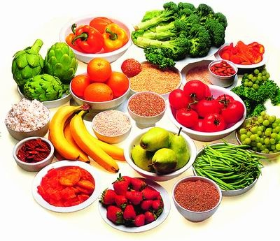

What type of student is best suited to How will I be assessed?
this course?

This GCSE course comprises of 3 units:
- Principles of Food Preparation: Written examination – 1 hour and 30 minutes, worth 50%
- Investigation Assessment 1 – 8 hours, worth 15%
- Food Preparation Assessment 2 – 12 hours, worth 35%
This specification builds on subject content which is typically taught at Key Stage 3 and provides a suitable foundation for the study of Food and Nutrition at Level 3. It also provides a coherent, satisfying and worthwhile life skills course for learners who do not wish to progress to further study in this subject.

What qualification will I gain?
What will the home learning be like?
What could I do with this qualification?

This specification will help learners make informed decisions about a wide range of career pathways.

This qualification could lead on to a course of further study for students wishing to become a:
chef
dietary technician
teacher
food scientist
Weekly investigatory home learning will be given.

A Food Hygiene Certificate Level 2 will be completed as part of the home learning.

What websites, books and other resources will help with my learning?

Text books titled EDUQAS GCSE Food and Nutrition are available to buy from leading bookshops.

Further information can be found on www.eduquas.co.uk.

Geography

What will I be taught?
AQA
This exciting and relevant course studies geography in a balanced framework of physical and human themes and investigates the link between them.

Students will travel the world from their classroom, exploring case studies in the United Kingdom (UK), higher income countries (HICs), newly emerging economies (NEEs) and lower income countries (LICs). Topics of study include climate change, poverty, deprivation, global shifts in economic power and the challenge of sustainable resource use. Students are also encouraged to understand their role in society, by considering different viewpoints, values and attitudes.

Subject content:

Living with the physical environment
The challenge of natural hazards
The living world
Physical landscapes in the UK
Challenges in the human environment
Urban issues and challenges
The changing economic world
The challenge of resource management
Geographical applications
Issue evaluation
Fieldwork
Geographical skills

Fieldwork:

Students will be given the opportunity to take part in a field study. The skills developed in this will then be assessed within an external exam at the end of the course.

What type of student is best suited to How will I be assessed?
this course?

Paper 1: Living with the physical environment. Examination 35%
Paper 2: Challenges in the human environment. Examination 35%
Paper 3: Geographical applications. Examination 30%
You will be inquisitive, analytical, critical, logical and resourceful. You will have a desire to solve problems on both a global and local scale. You want to ask where things are located and why? You care about people and the environment.

What qualification will I gain?
What will the home learning be like?
What could I do with this qualification?

By successfully completing this course you will gain a Geography GCSE. Geography at GCSE is an acceptable qualification for many jobs. Many careers require a number of examination passes and Geography is always accepted. There are also many careers where the study of Geography can be a distinct advantage, e.g. engineering, armed services, tourism, teaching, astronaut, government and business.

Home learning is set regularly to complement and further enhance the learning in the classroom. It may be that you are required to do further research at home or you may be expected to complete practice exam questions. Home learning in Geography is carefully planned and varied.

What websites, books and other resources will help with my learning?

Mrs Flack

http://www.bbc.co.uk/schools/gcsebitesize/geography/

https://rctmoodle.org/pontyhigh/course/view.php?id=38

HISTORY

What will I be taught?
AQA Specification A
The GCSE History content comprises the following elements:

- one period study
- one thematic study
- one wider-world depth study
- one British depth study including the historical environment.

Component 1: Understanding the Modern World

In Section A you focus on two key developments in a country's history over at least a 50-year period.

In section B you study a wider-world depth study. This focuses on international conflict and tension.

Section A: Period studies - America, 1840–1895: Expansion and consolidation

Section B: Wider world depth studies – Conflict and tension, 1894-1918

Component 2: Shaping the Nation

In Section A you focus on a thematic study, which looks at key developments in Britain over a long period.

In section B you focus on a British depth study incorporating the study of a specific historical environment.

Section A: Thematic studies - Britain: health and the people.

- Section B: British depth studies including the historical environment - Norman England, 1066–c1100 including an investigation about Pevensey Castle.

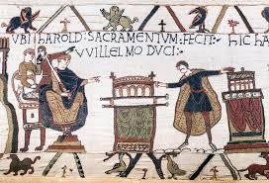

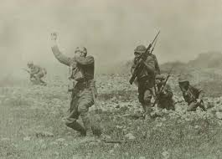

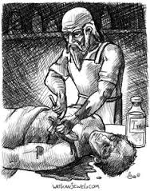

What type of student is best suited to How will I be assessed?
this course?

Both components have a written exam and are equally weighted.

2 written exams: 1 hour 45 minutes

Each paper has 84 marks (including 4 marks for spelling, punctuation and grammar).
The first thing that you need is a love of the past and a keen interest in the world and the people in it. History is a literacy based subject so you need to be prepared to write. Extended writing is a requirement for two questions on each examination paper.

What qualification will I gain?
What will the home learning be like?
What could I do with this qualification?

GCSE History is considered to be a very valuable qualification for all colleges and universities. It shows that a student has good literacy skills, but also proves that they can see many different sides of an argument, interpret evidence and reach a balanced judgement. These skills are essential in many careers, such as journalism, the law, teaching, accounting and media professions.
Whenever possible, home learning will allow you to practise core examination skills. There are many different question types in the GCSE examination and although we will be covering these in class it is essential that you practise them at home. Other tasks may involve research, redrafting and improving on class work.

What websites, books and other resources will help with my learning?

Websites
http://www.aqa.org.uk and search for HCSE History A.
http://www.bbc.co.uk has a wealth of useful resources.
http://www.schoolhistory.co.uk has a range of revision techniques and games.
Textbooks
Understanding the Modern World – David Ferriby – Hodder Education – ISBN 9781471862946
Norman England 1066 – 1100 – Helena Clarke – ISBN 9781471863424
Health and the People – Alf Wilkinson – ISBN 9781471864216
British Depth Studies – Tim Williams – ISBN 9781471864216
Revision Guide
GCSE AQA History - ISBN 9781782946045
GCSE Revision History British - Collins – ISBN 9780008166359
The AQA website will give you a good overview of the course content and there are many past examination papers.

Mathematics GCSE 1MA1 (9-1)

What will I be taught?
Edexcel
All students continue to study Mathematics in Years 9, 10 and 11. They follow a course leading to a GCSE in Mathematics.

All students will follow a linear course and there is no coursework to complete in this subject.

The topics covered are:

- Number

- Algebra

- Geometry and Measures

- Probability

- Statistics

- Ratio and Proportion

The Academy will provide students with online resources. Students are invited to purchase additional revision guides in addition to access to MathsWatchVLE and MyMaths resources. Students will use ICT and scientific calculators throughout the course. It is expected that students will provide their own mathematical equipment and will bring it to all Mathematics lessons. This should at least include an appropriate scientific calculator, geometry set containing at least an angle measure, a pair of compasses, pencils, pens, pencil sharpener, rubber and a 30cm ruler.

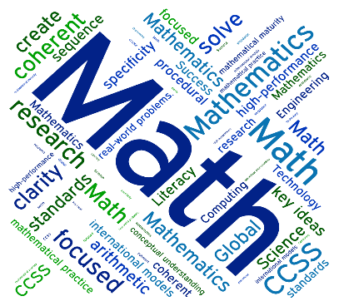

What type of student is best suited to How will I be assessed?
this course?

Assessment will be in the form of three 1 hour 30 minute papers at the end of Year 11. Each paper is worth 80 marks. There are two tiers: Foundation and Higher.
This is a core subject which is compulsory.

What qualification will I gain?
What will the home learning be like?
What could I do with this qualification?

Students will obtain a GCSE in Mathematics. They would be able to go on to study A Level Mathematics or the ‘Use of Mathematics’ course. Career opportunities are available in all job sectors including: environmental, science and engineering, health, sports and the traditional banking and finance. Advice on how to use a Maths qualification is available at www.mathscareers.org.uk.

Home learning is usually set as two pieces per week. Home learning tasks can be: completing an exercise, doing a past test paper, solving a range of problems, personal revision or research, depending on the topic being taught. Students will also have access to online website Pearson ActiveLearn to complete tasks and revision.

What websites, books and other resources will help with my learning?

Useful Resources/Websites:

www.pearsonactivelearn.com

www.mymaths.co.uk

www.mathswatchvle.com

www.corbettmaths.com

www.misbsresources.com

Revision guide and workbook for Edexcel

Media Studies

What will I be taught?
AQA
GCSE Media Studies is a more in-depth look into the media. Our students will explore three different areas of the media in order to complete their GCSE coursework and exams to a high standard: audio-visual, print and online forms.

During the course students will learn about each topic by analysing pictures and videos, planning new ideas of their own before creating practical work. There are also two written examinations to complete at the end of Year 11. Students also have a coursework assignment to complete.

Students have the opportunity to use computer programmes along with video and sound equipment to help them bring their media world to life.

Written Analysis

Students learn about the theory behind media. They analyse the media world around them using video clips, sound bites and the web too! Students use what they learn to talk in detail about music videos, a variety of films and advertising campaigns.

Planning Ideas

Throughout the course students will plan and develop their own ideas. Drawn designs and storyboards will help them create music videos, film posters and a filmed TV advert.

Production

Students have the opportunity to make posters and video pieces using camera or sound equipment along with the latest image manipulation programmes such as Photoshop. They will learn how to create professional and realistic designs that look like they belong in the real world!

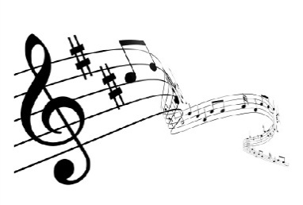

What type of student is best suited to How will I be assessed?
this course?

The GCSE course is 30% coursework in the form of a non –exam assessment. The work includes a statement and creating media product for an intended audience. The summer exam accounts for the remaining 70% of the qualification.
To succeed in Media Studies you will need a curious mind which questions everything you see and hear in the real world. Written skills are important for some of the course along with the ability to be creative. You must be willing to draw and use media technology.

What qualification will I gain?
What will the home learning be like?
What could I do with this qualification?

You will gain one GCSE qualification which could be used to pursue a media based qualification at college or in a future media job role.

Media-related careers include: animation, photography, web-based design, gaming programmer, roles in TV such as advertising, camera and sound as well as film jobs, plus many more!
Home learning in GCSE Media Studies takes the form of a series of worksheets based around the current topic. The tasks you will be asked to do could be either written or drawn.

What websites, books and other resources will help with my learning?

- www.imdb.com – details on all film including cast, trivia and plot information
- www.nmauk.co.uk – newspaper and magazine resources
- GCSE Media Studies - editors: Clark, Harvey - Longman, 2002
- The Media Student’s Book(third edition) - Branston/Stafford, Routledge, 2002
- Studying the Media - O’Sullivan/Dutton/Rayner, Arnold 1998
- Media Studies for GCSE - Wall/Walker, Collins 1997
- GCSE Media Studies - Bowker, Hodder 1999
- Media Studies, an Introduction - Dutton/Mundy, Longman 1995
- Media Research Techniques - Berger, Sage 1998
- A Dictionary of Communication and Media Studies, Arnold 1997

BTEC Tech Award Level 1/2 in Music Practice

What will I be taught?
Pearson
As an industry, music covers and includes a phenomenal amount of different jobs. This BTEC is successful as it appeals to a wide range of interests as some students have a passion in performing, others may prefer to learn how to become a composer/song-writer whereas some will want to focus on using computer software to create music. The course has two internally assessed components and one externally assessed component (there is no written exam).

Component 1: Exploring Music Products
Through a series of workshops and practical tasks, you will create a portfolio exploring a variety of styles and genres of popular music (such as disco, punk, reggae, pop ballads, RnB, Rock), world music, music for film and games, western classical styles and blues. Through these practical workshops, listening and theory elements will also be developed. The aim of this component is to capitalise on, nurture and encourage your own musical interests.

Component 2: Music Skills Development
You will specialise in two different areas out of these three: Music Performance, Creating Original Music (song writing/composing) and Music Production (using computer software to produce music).

Component 3: Responding to a Commercial Music Brief
This component will allow you to work to your strengths and interests and apply the skills that you have learned throughout your course in a practical way. You will focus on a particular area of the music industry that excites and appeals to you and respond to a commercial music brief as a composer, performer or producer.

The BTEC Level 2 Tech Award has the exact same worth/points as a GCSE. The grading is Distinction+, Distinction, Merit, Pass. This is equivalent to 8/9 for Distinction+, 7 for Distinction, 5/6 for Merit, 4 for Pass and 3 for Level 1.

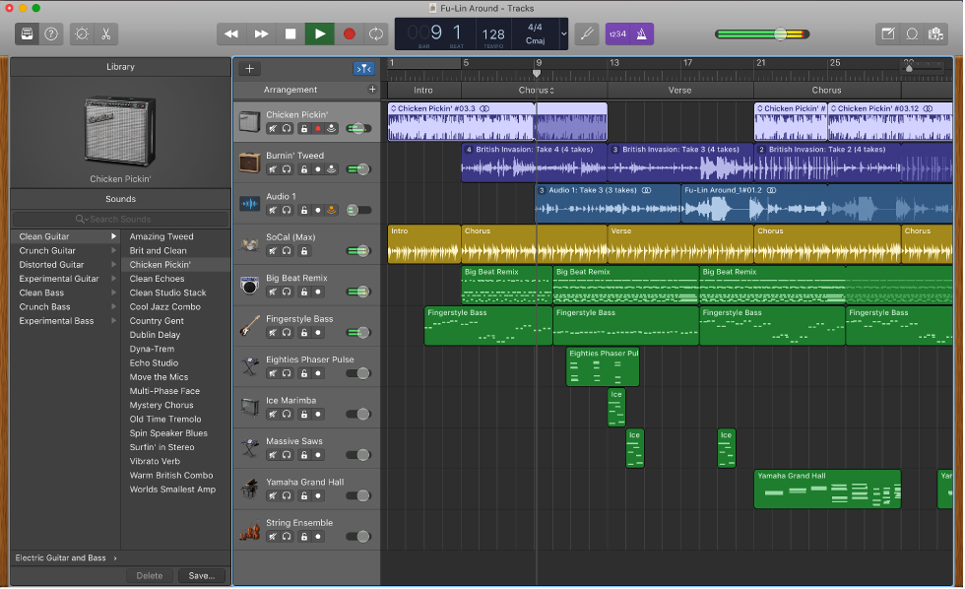

What type of student is best suited to How will I be assessed?
this course?

The course has two internally assessed components, and one that’s externally assessed. The externally assessed unit is not a written exam paper but instead the assessment takes the form of a set task taken under supervised conditions, which is then sent away to be marked.
Music is both a highly academic and highly creative subject. It is recommended that you take formal instrumental lessons with a qualified teacher on your instrument or voice. You should be passionate about learning an instrument or singing, and open to learning about all styles of music, writing your own music and performing in front of others.

What qualification will I gain?
What will the home learning be like?
What could I do with this qualification?

The BTEC Music qualification could lead to a career in performance, recording, music production, music business, band management, music journalism, music therapy, teaching etc. The BTEC Music qualification allows you to progress to Level 3 RSL and BTEC courses, A Level Music and Music Technology courses, and higher education courses such as degrees in Music, Popular Music, Music Technology and Music Business.
Home Learning will be set weekly and will incorporate the three key areas of music: performing, composing and theory.

Activities may relate to music theory and Styles of Music covered. In addition, students are expected to practice on their principal instrument for at least 15 minutes per day.

What websites, books and other resources will help with my learning?

There are many books, websites and other resources that will help you with your learning, some being more specific than others.

Music Theory – To gain a good understanding of music theory (the way we read, write and understand music) you would be advised to look at the Music Theory in Practice series of workbooks published by The Associated Board of the Royal Schools of Music. These are supplemented by The AB Guide To Music Theory and can be purchased from all good music shops or accessed through Thurrock Public Libraries.

Instrumental tuition & associated resources – Instrumental music lessons are available at the Academy through Thurrock Music Services. For students studying music at KS4, instrumental tuition (including voice) can be subsidised. It is recommended that all KS4 learners take instrumental lessons. Your instrumental teacher will recommend specific books and exercises that will help you to extend your own learning in and out of instrumental lessons.

Music GCSE

What will I be taught?
OCR
GCSE Music is a course which helps you develop your understanding of music through the skills of performing, composing, listening and appraising.

Unit 1 – Integrated Portfolio
Unit 1 focuses on your creativity as a musician, incorporating a solo performance on the learner’s chosen instrument and a composition to a brief set by the learner.

Unit 2 – Practical Component
Unit 2 looks at responding to a set brief and working with others. This includes an ensemble performance and a composition to an OCR set brief.

Unit 3 – Listening and Appraising
Unit 3 targets our four Areas of Study, each with suggested listening. During this unit you will learn how the pieces of music are constructed and how they relate to other pieces of music from the same period(s):

The Concerto Through Time

Rhythms of the World

Film Music

Conventions of Pop

This unit also incorporates aural skills and the learner’s ability to dictate music heard, as well as identify key features in music.

Students interested in taking GCSE Music will be asked to take a 10-minute aptitude test to identify performance level and aural skills.

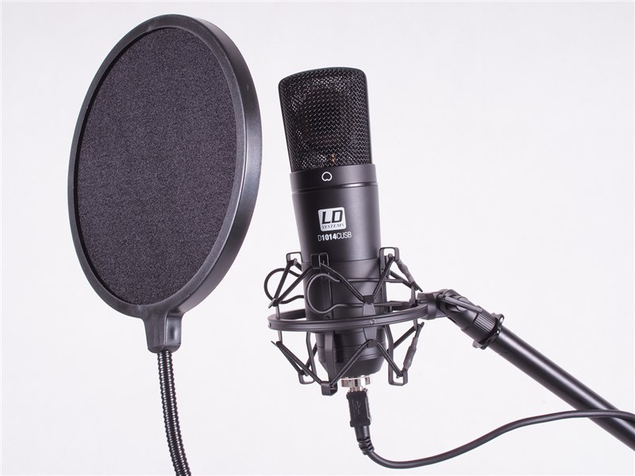

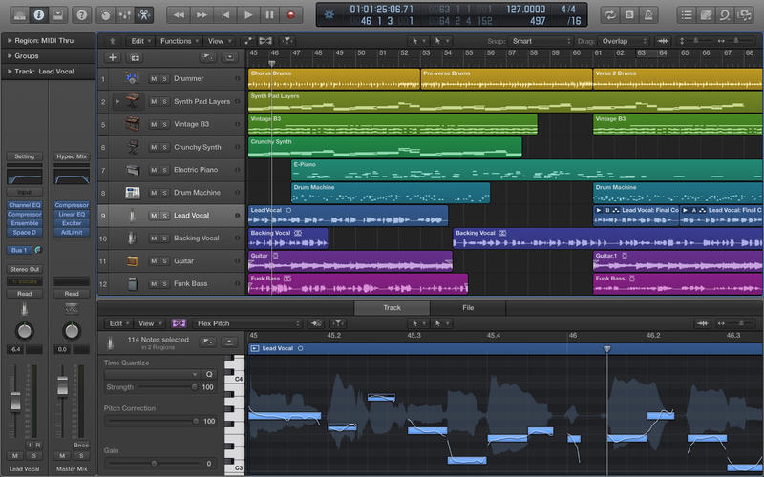

What type of student is best suited to How will I be assessed?
this course?

Assessment is through three units. Units 1 and 2 focus on controlled assessment or coursework, which is assessed by your Music teacher and moderated by the examination board. Unit 3 is assessed by a formal examination which is sat in May of the final year of the course. The examination comprises short answers and essay-style questions.

GCSE Music is a largely practical course. Students taking it will already be able to perform at an intermediate level on an instrument/voice and be receiving instrumental tuition to help improve their performance level. They will have a genuine interest in listening to all styles of music, performing on their own instrument and creating new music of their own.

What qualification will I gain?
What will the home learning be like?
What could I do with this qualification?

Successful completion of the course will lead to you being awarded a GCSE in Music. From this course, you could easily go on to study a BTEC Level 3 (GCE ‘A’ Level standard) in Music or Music Technology, an NCFE in Music Technology or even GCE Advanced Level Music.

This can go further, leading to university courses at different establishments across the country.

It is expected that all students practice on their principal instrument for at least 15 minutes per day. This helps to maintain their own performance level and advance it between lessons.

Other home learning activities and exercises will relate to music theory exercises and to the pieces of music studied for each Area of Study.

What websites, books and other resources will help with my learning?

There are many books, websites and other resources that will help you with your learning, some being more specific than others.

Music Theory – To gain a good understanding of music theory (the way we read, write and understand music) you would be advised to look at the Music Theory in Practice series of workbooks published by The Associated Board of the Royal Schools of Music. These are supplemented by The AB Guide To Music Theory and can be purchased from all good music shops or accessed through Thurrock Public Libraries.

Instrumental tuition & associated resources – Instrumental music lessons are available at the Academy through Thurrock Music Services. For students studying music at KS4, instrumental tuition (including voice) can be subsidised. It is recommended that all KS4 learners take instrumental lessons. Your instrumental teacher will recommend specific books and exercises that will help you to extend your own learning in and out of instrumental lessons.

Music Technology

What will I be taught?
NCFE Level 2
The NCFE Level 2 Technical Award in Music Technology enables learners to develop skills, knowledge and understanding of the music technology industry. It is suitable for learners who are motivated and challenged by learning through hands-on experiences. The qualification will allow learners to gain practical skills in creating music using technology. The Level 2 Technical Award is aimed at 14-16 year olds with an interest in music production and recording and is designed to sit alongside GCSEs in the Key Stage 4 curriculum. It is a vocational qualification equivalent to GCSE at grades 9-4. The qualification provides an introduction to the music technology industry and enables learners to acquire, develop and apply skills and knowledge required for further academic and/or vocational study.

What will the learner study as part of this qualification? This qualification shows learners how to:

- set up and use a Digital Audio Workstation (DAW)
- create a musical project to a specified brief, using audio and MIDI editing tools
- understand and experiment with musical elements in a chosen style
- plan and undertake a studio recording session
- use mixing techniques to make a multi-track recording
- explore sound creation.

What knowledge and skills will the learner develop as part of this qualification and how might these be of use and value in further studies? Learners will know about:

- hardware components and software functions
- musical elements of a chosen style
- cultural developments that have influenced their chosen style
- planning a recording session
- sound creation.

They will develop skills in: creating music using MIDI and audio in a particular style, using different software and equipment to create music plus many more skills and abilities.

What type of student is best suited to How will I be assessed?
this course?

Unit 1 – Using a Digital Audio Workstation (DAW): Internally assessed and externally assessed
Unit 2 – Creating Music: Internally assessed and externally assessed
Unit 3 – Sound Recording: Internally assessed and externally assessed
Unit 4 – Sound Creation: Internally assessed and externally assessed
Working in music technology is often driven by a passion for the pleasures that music can bring. Performing is not the only way to get into music; the role of technology is central to most performances and a wide variety of jobs exist as part of the technical team behind a track.

What qualification will I gain?
What will the home learning be like?
What could I do with this qualification?

Learners who achieve the NCFE Level 2 Technical Award in Music Technology could progress to Level 3 qualifications and A Levels such as:
- NCFE Level 3 Applied General Certificate in Music Technology
- NCFE Level 3 Diploma in Creative Media
- NCFE Level 3 Extended Diploma in Creative Media
- A level Music
- A level Music Technology
Home learning will vary with each unit but will include some of the following:

*Research
*Completing workbooks
*Understanding music production

What websites, books and other resources will help with my learning?

Students will use a wide variety of resources that will be supplied with each unit. This will provide a solid background for learners. Below are some of the resources that learners will have access to:
- iAchieve
- PiXL
- ForSkills
- Study Hut

GCSE Photography

What will I be taught?
OCR
GCSE Photography is aimed at turning students into accomplished photographers. The Art department’s aim is to develop students’ ability to take an excellent photograph, to enable them to use Adobe Photoshop and to think creatively and analytically about photography.

Students will be introduced to the basics of photography including how to compose a photograph, the use of lighting and different camera functions. They will gain a better knowledge and understanding of how to use Adobe Photoshop.

Students will respond critically and creatively to a wide range of photographers. They will be encouraged to work independently with a strong focus on producing work that is personal to them.

We recommend that students have their own digital cameras and if they have access to Adobe Photoshop that would enable them to progress even faster.

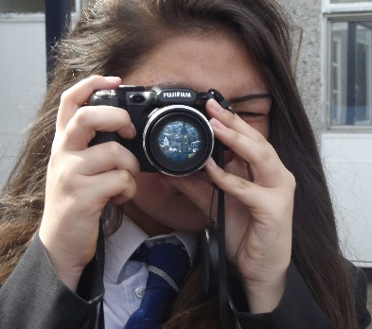

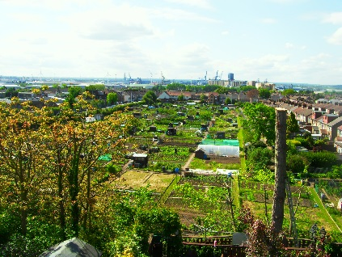

What type of student is best suited to How will I be assessed?
this course?

Course Assessment: 60% portfolio 40% exam. Students will work on two projects for their portfolio; they will choose one and develop this as their portfolio. The exam involves 10 weeks of preparatory work based around a theme given to students by the exam board. Students must conclude this project with a 10 hour exam which is an overview of their work.
A student who is passionate about photography, who enjoys thinking creatively and creating work that they can be proud of. A student who is not afraid to make mistakes and take risks with their ideas.

What qualification will I gain?
What will the home learning be like?
What could I do with this qualification?

Qualification gained: GCSE Photography.

Students could use this qualification to pursue a career in the creative industries. Careers in the arts include: photographer, fine artist, graphic designer, illustrator, web designer, film director, set designer, animator, product designer, Art teacher, visual FX artist.
Home learning will be given every two weeks in the first half term of the course based around developing the initial skills learnt. It then becomes much more of an independently driven exercise and students are given individualised tasks. Those who obtain the best grades go above and beyond these tasks and produce their own work inspired by the themes. One hour a week is the recommended time to be spent on Home learning.

What websites, books and other resources will help with my learning?

Books: Websites:
The Art Book published – Phaidon www.tate.co.uk
BBC Bitesize GCSE Art and Design www.npg.org.uk
The Twentieth Century Art Book - Phaidon www.saatchigallery.com
Art Now - Taschen www.thisicollassal.com
50 Photographers You Should Know - Prestel
50 Artists You Should Know - Prestel
50 British Artists You Should Know - Prestel
50 Contemporary Artists You Should Know - Prestel
Creative Paint Workshop for Mixed-Media Artists - Ann Baldwin
Artists’ Journals and Sketchbooks - Lynne Perella
Extraordinary Sketchbooks - Jane Stobart

Physical Education - Core

What will I be taught?
This subject will not be examined
During core PE students will take part in a variety of different sports and will cover the following:

- Skills
- Tactics
- Rules, regulations and scoring systems
- Officiating
- Coaching

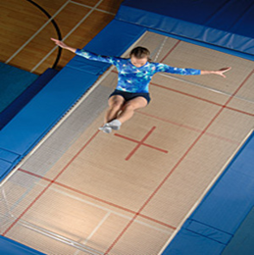

What type of student is best suited to How will I be assessed?
this course?

Formal assessment of core PE does not take place; however, the following are closely monitored:
- Engagement in learning
- Participation
- Fitness
- Progress of skills
- Behaviour

What qualification will I gain?
What will the home learning be like?
What could I do with this qualification?

You will not gain a qualification in core PE.

The skills you gain in core PE will help with enrichment courses such as games at college.
Home learning will not be set.

What websites, books and other resources will help with my learning?

www.topendsports.com

www.brianmac.co.uk

www.bbc.co.uk/sport

www.thefa.com/

www.rfu.com/

GCSE Physical Education

What will I be taught?
Edexcel
Students will study the following units during the course:

- Applied anatomy and physiology
- Movement analysis
- Physical training
- Using data
- Health, fitness and well-being
- Sport Psychology
- Socio-cultural influences in sport
- Use of data
- Practical sport

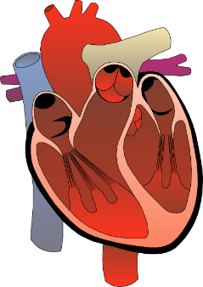

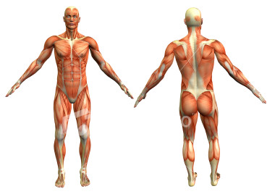

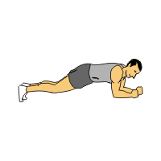

What type of student is best suited to How will I be assessed?
this course?

Component:
1. Fitness & Body Systems
Assessed by a 1 hr 45 written exam
2. Health & Performance
Assessed by a 1 hr 45 written exam
3. Practical performance
Assessed by three practical sport assessments
4. Personal Exercise Programme
Assessed through coursework
GCSE Physical Education is suitable for students that are good at practical sport and have a keen interest in sport and exercise. Students need to be aware that this course does have a heavy theory content, so it is not just playing sport.

What qualification will I gain?
What will the home learning be like?
What could I do with this qualification?

The qualification that you receive for this course is a GCSE. Depending on the grade you receive you would be able to go on to college to study either A levels or a BTEC Sport course.
Home learning will involve research related to the unit being studied, exam questions and revision.

What websites, books and other resources will help with my learning?

www.topendsports.com

www.brianmac.co.uk

www.bbc.co.uk/sport

www.thefa.com/

www.rfu.com/

www.bbc.co.uk/bitesize/gcse/pe

Double Science GCSE (Combined Science Trilogy)

What will I be taught?
AQA

In this course you will study:

Biology

Cellular biology and organisation where you will have the opportunity to look at cells under the microscope. You will also study infection and the body’s response to foreign particles. The module covers bioenergetics, homeostasis and genetics. Ecology forms a big part of the module where you will learn about the impact of humans on the environment.

Chemistry

You will study the structure of the atom and the evolution of the periodic table. You will have the opportunity to study properties of matter and the energy changes that occur in various chemical reactions. The module includes organic chemistry, chemical analysis of unknown substances and chemistry of the environment.

Physics

You will study various forces and their effects. You will experiment on car safety features and the effect of resistance on current. You will also study energy, waves and electricity. The module includes further practical work on magnets and electromagnets.

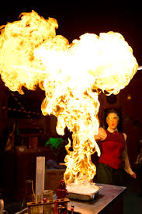

What type of student is best suited to How will I be assessed?
this course?

Over the two years you will study the Combined Science Trilogy course. At the end of Year 11 you will sit your exams. These will consist of 2 Biology papers, 2 Chemistry papers and 2 Physics papers. Each paper consists of multiple choice, structured, closed short answer, and open response questions. Each paper makes up 16.7% of the GCSE.
This course is suited to students who wish to pursue A-level Biology, Chemistry or Physics. Students who follow this course need to be able to effectively research topics and analyse information to help them draw important scientific conclusions. Students also need to be able to evaluate information as the course focuses heavily on exams.

What qualification will I gain?
What will the home learning be like?
What could I do with this qualification?

In this course you will achieve 2 GCSE Science grades.

A qualification in Combined Science Trilogy allows you to consider any of the following careers:

Formula One mechanic, snowboard design, stage lighting design, fighter pilot, cosmetic industry, jewellery production, medicine and paramedic.
Home learning will focus on the use of workbooks and online study tasks to cement students’ understanding of the content. Home learning will also include research skills and interpreting long answer questions in order to build student confidence in exam technique.

What websites, books and other resources will help with my learning?

BOOKS:

- Biology For You
- Chemistry For You
- Physics For You
- AQA Science by Nelson Thornes

WEBSITES:

- http://www.aqa.org.uk/subjects/science
- http://www.bbc.co.uk/schools/gcsebitesize/science/
- http://www.docbrown.info/page10/page10.htm

Statistics GCSE (9-1) 1ST0

What will I be taught?
Edexcel
GCSE Statistics allows you the opportunity to apply your understanding of data to solve problems and analyse outcomes.

The skills and knowledge acquired will be relevant and transferable to other subjects. Students are introduced to the skills of statistical enquiry, and practise the underpinning statistical calculations and interpretation using real world data and authentic contexts. The course will include case studies and practical tasks. Many A Level courses will require your skills as an independent learner and you will be helped to become a critical and reflective thinker.

The course content is divided into the following aspects:

- Analysing a problem and planning an appropriate strategy.

- Describing and using appropriate methods to communicate efficiently.

- Understanding how technology has enabled the collection, visualisation and analysis of large quantities of data to inform decision-making processes in public, commercial and academic sectors, including how technology can be used to generate diagrams and visualisations to represent data.

- Processing and analysing evidence to draw conclusions and reflect on the outcomes.

- Considering the impact of chance on outcomes.

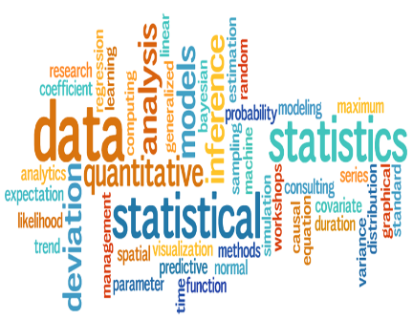

What type of student is best suited to How will I be assessed?
this course?

Paper 1 (*Paper code: 1ST0/1F and 1ST0/1H)
Written examination: 1 hour and 30 minutes - 50% of the qualification
80 marks
Paper 2 (*Paper code: 1ST0/2F and 1ST0/2H)
Written examination: 1 hour 30 minutes - 50% of the qualification
80 marks
Students with a keen interest in Mathematics will be suited to this course. Students who enjoy investigating data and who want to further explore mathematics in real life scenarios will benefit from this course.

What qualification will I gain?
What will the home learning be like?
What could I do with this qualification?

Students will obtain a GCSE in Statistics. Career opportunities are available in all job sectors including: environmental, science and engineering, health, sports and the traditional banking and finance. Advice on how to use a Maths qualification is available at www.mathscareers.org.uk.
Home learning will be set once a week for an hour. Home learning tasks can be: completing an exercise, doing a past test paper, solving a range of problems, personal revision or research, depending on the topic being taught. Students will also have access to on-line website Pearson Active Learn to complete tasks and for revision.

What websites, books and other resources will help with my learning?

Useful Resources/Websites:

Edexcel GCSE Statistics

CGP Statistics Revision Guide

Revision Booklet Statistics for Dummies

www.mathswatchVLE.com

www.mymaths.com

www.corbettmaths.com

