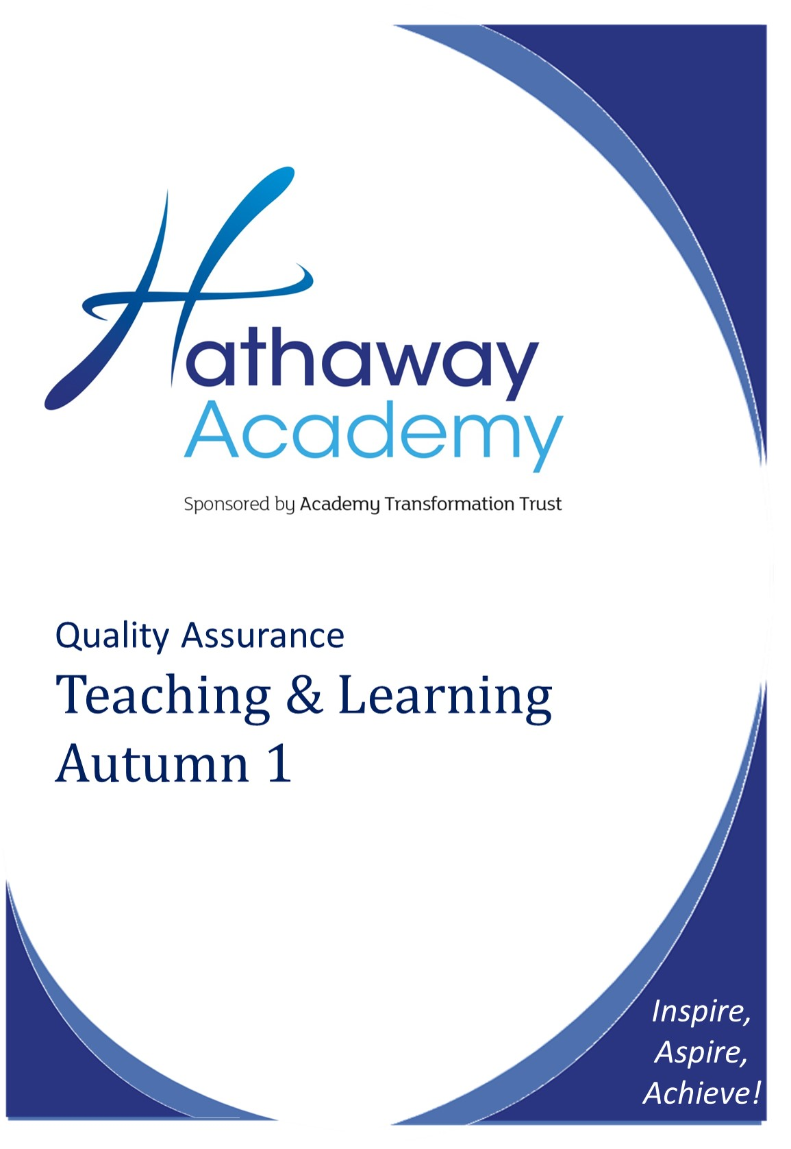

Examination Contingency Plan

Centre Number: 16709

Purpose of the plan …2
Causes of potential disruption to the exam process 2
- Exam officer extended absence at key points in the exam process 2
- SENCo extended absence at key points in the exam cycle 2
- Teaching staff extended absence at key points in the exam cycle 2
- Invigilators - lack of appropriately trained invigilators or invigilator absence 3
- Exam rooms - lack of appropriate rooms or main venues unavailable at short notice 3
- Failure of IT systems 3
- Centre unable to open as normal during the exams period 3
- Candidates unable to take examinations because of a crisis – centre remains open 3
- Disruption to the transportation of completed examination scripts 4
- Assessment evidence is not available to be marked 4
- Centre unable to distribute results as normal 4

Purpose of the plan
This plan examines potential risks and issues that could cause disruption to the management and administration of the exam process at The Hathaway Academy. By outlining actions/procedures to be followed in case of disruption it is intended to mitigate the impact these disruptions have on our exam process.
Alongside internal processes, this plan is informed by information contained in the Joint contingency plan for the examination system in England, Wales and Northern Ireland where it is stated that “Centres should prepare plans for any disruption to examinations as part of their general emergency planning. It is important to ensure that relevant centre staff are familiar with the plan. Consideration should be given as to how these arrangements will be communicated to candidates, parents and staff should disruption to examinations occur.”

Causes of potential disruption to the exam process

- Exam officer extended absence at key points in the exam process

The department is structured with an Exams Officer, a part-time Exams Officer and overseen by the Data and Curriculum Manager.

In a period of extended absence the part-time Exams Officer would take responsibility for carrying out the duties of the Exams Officer and would work in consultation with the Data and Curriculum Manager. Appropriate back-filling of responsibilities would then be decided upon by the Data and Curriculum Manager. All members of the invigilating team regularly receive training and colleagues involved in the administration of key processes are trained on how to carry out processes and who to contact in extremis.

- SENCo extended absence at key points in the exam cycle

In the event of the extended absence of the SENCo, appropriate back-filling of responsibilities would be decided upon by the Principal who is the Head of Centre.

- Teaching staff extended absence at key points in the exam cycle

In the event of a period of extended absence of a member of the teaching staff, the Co-ordinator for the curriculum area would arrange teaching cover from within the staff team and/or the wider staffing establishment at the Academy. New staff providing cover would be briefed as part of their induction process on arrangements for assessment and examinations. Their practice in terms of assessments would be monitored by the Co-ordinator.

- Invigilators - lack of appropriately trained invigilators or invigilator absence

New invigilators undergo training by the Exams Officer and complete a period of shadowing, following appointment. They are permitted to work independently once they, and the Exams Officer are happy that they are competent and confident in processes and procedures. Annual training sessions are held in October for all invigilators in order to refresh their knowledge and communicate JCQ regulation changes and update local information. The Academy retains a pool of approximately 10 invigilators. When invigilators resign/retire from the pool, recruitment procedures are begun. Within the wider Academy staff, colleagues are required to assist during main exam sessions (mainly GCSE English and Mathematics) and are trained by the Exams Officer with regard to their responsibilities and duties. Minor absence issues (such as an invigilator calling in sick) are covered by a member of the Exams team or attempts are made to contact another invigilator from the pool.

- Exam rooms - lack of appropriate rooms or main venues unavailable at short notice

The majority of exams are accommodated in the Sports Hall, Gym and standard size classrooms/ICT suites and the exam team works closely in order to utilise rooms effectively.

- Failure of ICT systems

The Academy endeavors to minimise any ICT disruption via resilient design and preventative maintenance. In the event of an issue this would be dealt with the ICT support team who test and update the systems on a regular basis. Where such failure impacted on scheduled exams, steps would be taken to resolve the problem as quickly as possible.

- Centre unable to open as normal during the exams period

In the event of the Centre not being able to open as normal, appropriate communication with the relevant Awarding Bodies would be undertaken by the Exams Officer and alternative options would be explored such as moving exams to an external location (such as leisure centres, hotels, local schools, etc. and appropriate transport arrangements would be made). All arrangements would be agreed with the Awarding Body before being put in place. In such instances, details would be communicated to candidates via the school’s website, email and text facilities. Staff involved in exams (including invigilators) would be contacted by email, telephone and text.

- Candidates unable to take examinations because of a crisis – Centre remains open

Response is dependent on the type of issue. The procedure for absence is outlined in the examinations policy. A hardcopy is given to all candidates in April of each academic year and is available on the Academy’s website. If a candidate is able to sit the exam but cannot attend the Centre due to a crisis, appropriate communication with the relevant Awarding Bodies would be undertaken by the Exams Officer and alternative options would be explored (home, hospital, alternative Centre etc.). Appropriate use of Special Consideration policies would be applied should the candidate/candidates be unable to attend due to unforeseen circumstances and where alternative arrangements could not be made or are not agreed by the Awarding Body.

- Disruption to the transportation of completed examination scripts

All scripts are returned using the designated dispatch methods prescribed by the Awarding Body concerned. Where this becomes unavailable or inappropriate, the Awarding Body will be contacted to discuss suitable alternatives.

- Assessment evidence is not available to be marked

In the event of large scale damage or destruction of completed examination scripts/assessment evidence before it can be marked, the Exam Officer would notify the Awarding Body immediately for advice and further instructions. Student marks would be submitted based on appropriate evidence and candidates would be given the opportunity to retake in a subsequent series.

- Centre unable to distribute results as normal

The Centre distributes the results ‘as normal’ via collection by learner. Where learners do not collect results in person, these will distributed via post.

Further guidance to inform and implement contingency planning
Ofqual
Joint Contingency Plan in the event of widespread disruption to the Examination System in England, Wales and Northern Ireland http://dera.ioe.ac.uk/16235/1/2012-12-11-joint-contingency-plan-november-2012.pdf

GOV.UK
Emergencies and severe weather: schools and early years settings https://www.gov.uk/emergencies-and-severe-weather-schools-and-early-years-settings
Teaching time lost due to severe weather conditions https://www.gov.uk/government/publications/teaching-time-lost-due-to-severe-weather-conditions/teaching-time-lost-due-to-severe-weather-conditions
Dispatch of exam scripts guide - Contingency planning https://www.gov.uk/government/publications/dispatch-of-exam-scripts-yellow-label-service/dispatch-of-exam-scripts-guide

JCQ
Guidance on alternative site arrangements http://www.jcq.org.uk/exams-office/forms
Instructions for conducting examinations http://www.jcq.org.uk/exams-office/ice---instructions-for-conducting-examinations
Guidance on access arrangements and special consideration http://www.jcq.org.uk/exams-office/access-arrangements-and-special-consideration

Produced on behalf of: AQA, CCEA, OCR, Pearson and WJEC Notice to Centres – examination contingency plan/examinations policy
(For the attention of heads of centre, senior leaders and examination officers)

For the academic year 2015/16, and with effect from the June 2016 examination series onwards, all centres must have an examination contingency plan/examinations policy on file for inspection.

The examination contingency plan/examinations policy should cover all aspects of examination administration. It will allow senior leaders to have a robust contingency plan in place, minimising risk to examination administration and any adverse impact on students, should the examinations officer be absent at a critical stage of the examination cycle.

In order to reduce bureaucracy and burden for schools and colleges a particular format or template will not be specified. We believe that senior leaders within schools and colleges are best placed to determine their own examination contingency plan/examinations policy.

The Joint contingency plan for the examinations system in England, Wales and Northern Ireland, which can be downloaded from Ofqual’s website, (https://www.gov.uk/government/publications/exam-system-contingency-plan-england-wales- and-northern-ireland) is a good starting point. It will provide a framework for senior leaders to build and shape a plan/policy in light of their local circumstances.

